
NOTE: This is an official document by Indexademics. Unless otherwise stated, this document may not be accredited to individuals or groups other than the club IDX, nor should this document be distributed, sold, or modified for personal use in any way.
IDX G9 CHEMISTRY H STUDY GUIDE ISSUE 7
By Hayley and Allison

8.6 Resonance Structure

- Resonance: a condition that occurs when more than one valid Lewis sturcture can be written for a molecular ion
- Different only in the position of electron pairs, not the ATOM positions
- The actual structure of the molecule is a blend of all its resonance structures --> Resonance hybrid
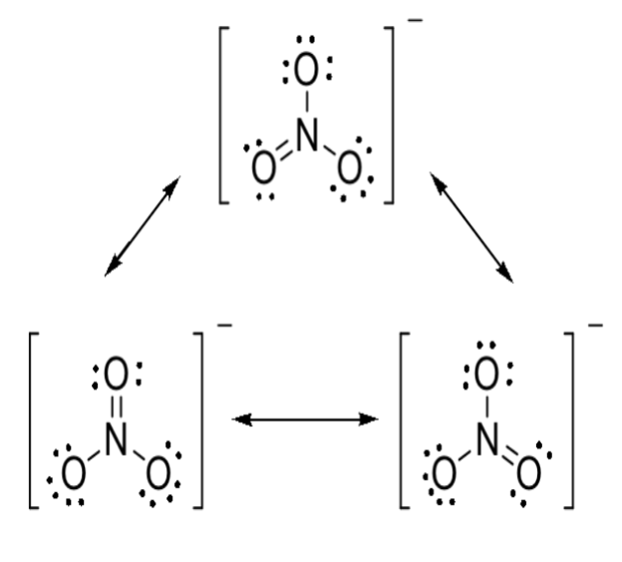
- Delocalized π bond is formed
- All bonds have the same length and bond dissociation energy
- Stronger than a single bond, weaker than a double bond
- E.g. CO₃²⁻ (3), SO₄²⁻(6), SO₂(2), NO₂⁻(2), O₃
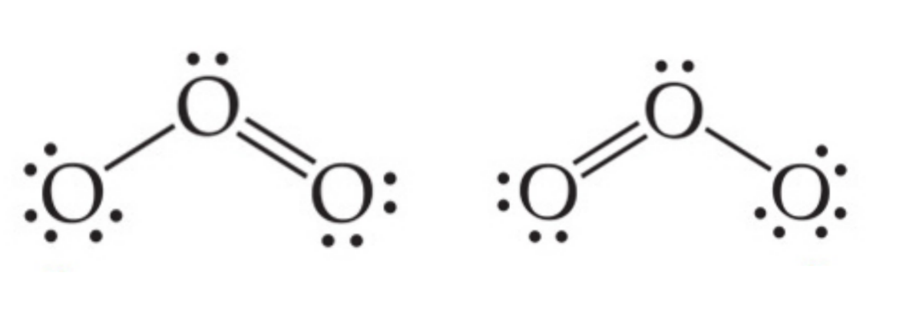

8.7 Exceptions to the Octet Rule

- Odd number of electrons
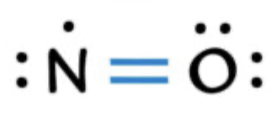
- Fewer than 8 electrons
- E.g. Boron Trifluoride (BF₃)
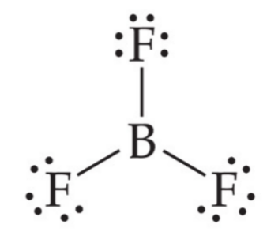
- Can form coordination covalent bond with NH₃
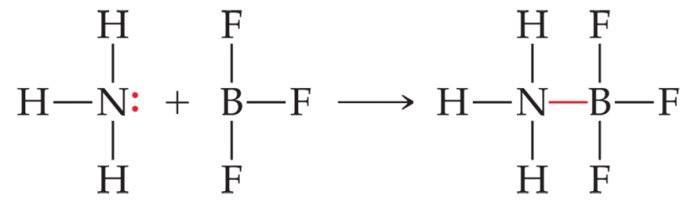
- Coordinate Covalent Bond
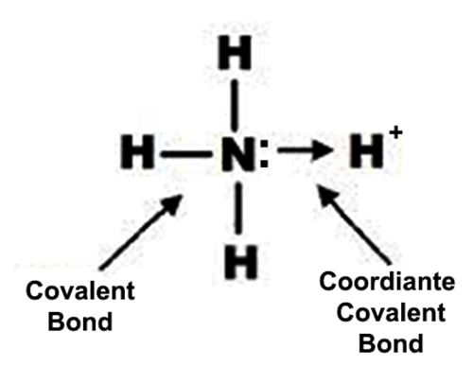
- Bond formed when both electrons donated by the same atom (usually use an arrow to represent)

- More than 8 electrons
- An expanded octet is used by considering the d orbital that occurs in the energy level of elements in 3th period or higher.
- E.g. PCl₅ ,SF₆, XeF₄
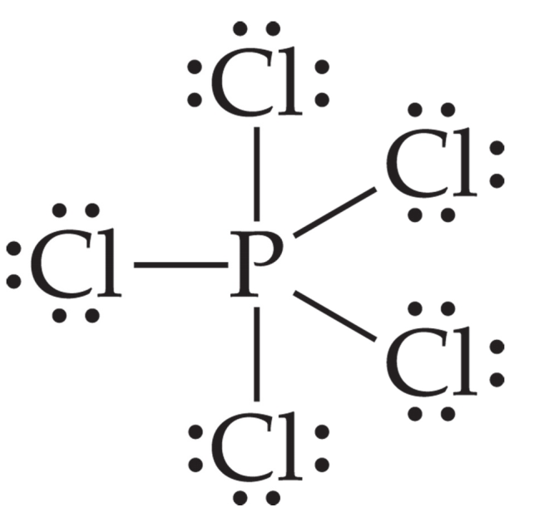

Chapter 8 Supplementary: Names and Formulas

- Names and Formulas of Ionic Compounds
  - Formulas
- Formula unit: used to represent the ratio of cations to anions in the ionic compounds
  - Overall charge is zero
  - Monoatomic and polyatomic ions
- Oxidation number: the number given to indicated whether an element has been reduced or oxidized in a redox reaction
  - Equal to charge of a monoatomic ion
  - Equal to the number of electrons transferred from an atom of the elements to form the ion in an ionic compound
  - Sum equals to zero in a neutral compound and the charge of the ion in a polyatomic ion
  - Naming
    - Monoatomic ions
  - Cations: same name as the metal
    - i.e. K+ potassium ion, Fe2+ and Fe3+ iron (II) ion and iron (III) ion
  - anions: replace end of name with “-ide”
    - i.e. Cl- chloride ion, P3- phosphide ion
    - Polyatomic ions
  - Oxyanions: polyatomic ions composed of an element, usually a nonmetal bonded to one or more oxygen atoms
  - Two forms
    - More O atoms “-ate” (most common)
    - On less O atom “-ite”
    - i.e. NO3- nitrate, NO2- nitrite
  - four forms
    - most O atoms “per-” “-ate” (one more O)
    - most common “-ate”
    - one less O atom “-ite”
    - two less O atoms “hypo-” “-ite”
    - i.e. ClO4- perchlorate, ClO3- chlorate, ClO2- chlorite, ClO- hypochlorite
    - Ionic compounds
  - Name of cation + name of anion
- Naming Molecules
  - Binary Molecular Compounds
- First element named first with entire element name
- Second element named with root of element and “-ide”
- Prefixes for the numbers of atoms (don’t use mono- for the first element)
  - Mono-, di-, tri-, tetra-, penta-, hexa-, hepta-, octa-, nona-, deca- (1-10)
  - Acids
- If the compounds produced H+ in the solution acid
- Hydro + root of second element + ic + acid
  - i.e. HCl hydrochloric acid
- hydro + root of second polyatomic ion + ic + acid
  - i.e. HCN hydrocyanic acid
  - Oxyacids
- Oxyacid: any acid containing hydrogen and ocygen
- “-ate” “-ic” acid, “-ite” “-ous” acid

